Online - Unit of Work  Class: Stage 3 Term: Term 1 Week: Week 11 | 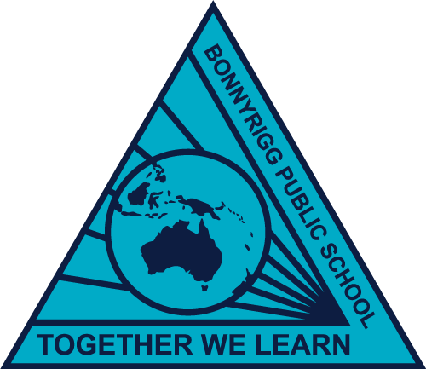

 | Monday | Tuesday | Wednesday | Thursday | Friday
Morning | English  Spelling/Grammar  - Watch SMART spelling video on google classroom  - Spelling grid on google classroom.  Reading  - log on to PM eCollection and read the set book by your teacher (20 minutes)  Speaking & Listening  - Follow the assigned task on google classroom (pig the pug). Listen to the story.  Writing  - Complete the task about pig the pug task 1 | English  Spelling/Grammar  - Write out your words  - Choose 3 spelling choice board activities and complete into literacy book.  Reading  - Read the set novel on Epic (20 minutes)  Comprehension  - Complete comprehension task (what is bushfire) on google classroom. Answer questions in your literacy book. | English  Spelling/Grammar  - Write out your words  - Choose 3 spelling choice board activities and complete into literacy book.  Reading  - PM e-reader (20 minutes)  Speaking & Listening  - Follow the assigned task on google classroom (pig the pug). Listen to the story.  Writing  - Complete the task about pig the pug task 2 | English  Spelling/Grammar  - Spelling Test in literacy book. Complete test with a buddy at home.  Reading  - Read the set novel on Epic (20 minutes)  Comprehension  - Complete comprehension task (robot K-9) on google classroom. Answer questions in your literacy book. | Public Holiday
Break
Middle | Mathematics (number)  Log onto Khan academy (link in Email)  Complete assignment on khan academy. Topic: decimal place value intro | Mathematics (number)  Log onto Khan academy (link in Email)  Complete assignment on khan academy. Topic: decimals on the numberline and Quiz 1 | Mathematics (number)  Log onto Khan academy (link in Email)  Complete assignment on khan academy. Topic: comparing decimals and Quiz 3  FInd 5 - Find 5 things in your backyard that you can measure. Practice converting these measurements between millimetres, centimetres and metres. | Mathematics (measurement)  Log onto Khan academy (link in Email)  Complete assignment on khan academy. Topic: converting metric units  - Find 5 sticks, measure them in cm and record on google classroom  - measure the length of your back fence, counting your footsteps. Record on google classroom.
Break
Afternoon | Science  Stile: Complete a Food and Fibre lesson | Mindfulness  Cosmic yoga  https://www.youtube.com/watch?v=Wsy2L9VvX90  Watch and join in | History  Inquisitive:  5/6E- http://inq.co/class/kb6 Access code: 6977  5/6FS-  http://inq.co/class/kb6 Access code: 6977  5/6T | Creative Arts  Air Guitar and clapping to the tempo with Mr Taylor!  Record the tempo of some of your songs on Google Classroom.

