Offline - Unit of Work  Class: Stage 3 Term: Term 1 Week: Week 11 | 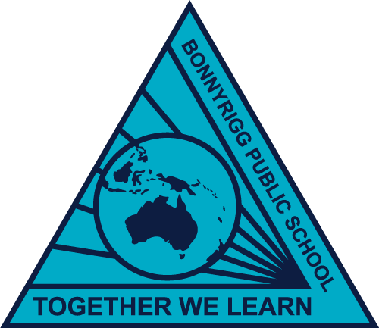

 | Monday | Tuesday | Wednesday | Thursday | Friday
Morning | English  Spelling/Grammar  - Watch SMART spelling video on google classroom  - Complete Spelling grid.  Reading  - Read your Novel for 20 mins  Writing  - Write down a summary of what you have read today. Your summary should be at least 5 Sentences. | English  Spelling/Grammar  - Write out your words  - Choose 3 spelling choice board activities and complete into literacy book.  Reading  - Read your Novel for 20 mins  Comprehension  - Complete comprehension task (what is bushfire) Answer questions in your literacy book. | English  Spelling/Grammar  - Write out your words  - Choose 3 spelling choice board activities and complete into literacy book.  Reading  - Read your Novel for 20 mins  Writing  - Write down a summary of what you have read today. Your summary should be at least 5 Sentences. | English  Spelling/Grammar  - Spelling Test in literacy book. Complete test with a buddy at home.  Reading  - Read your Novel for 20 mins  Comprehension  - Complete comprehension task (robot K-9). Answer questions in your literacy book. | Public Holiday
Break
Middle | Mathematics (number)  Complete Maths Worksheet - Fractions, Decimals and percentages - tenths and hundredths. | Mathematics (number)  Complete Maths Worksheet - Fractions, Decimals and percentages - Place value to thousandths | Mathematics (number)  Complete Maths Worksheet - Measurement - m, cm, mm and word problems. | Mathematics (measurement)  - find 5 sticks, measure them in cm and record on google classroom  - measure the length of your back fence, counting your footsteps. Record on google classroom.
Break
Afternoon | Creative Arts  Complete 2 activities from the Art Bingo activity | Creative Arts  Complete 2 activities from the Art Bingo activity | Creative Arts  Complete 2 activities from the Art Bingo activity | Creative Arts  Complete 2 activities from the Art Bingo activity

