Unit of Work  Class: Stage 2 Term: 1 Week: 11 | 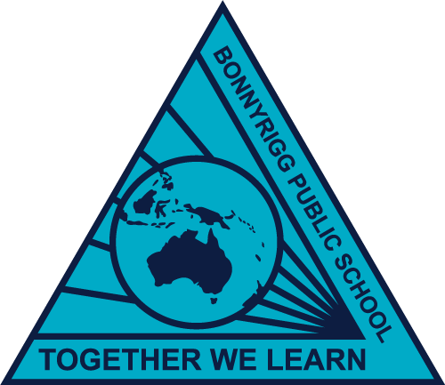

 | Monday  6/4/2020 | Tuesday  7/4/2020 | Wednesday  8/4/2020 | Thursday  9/4/2020 | Friday  10/4/2020
Morning | Handwriting – Booklet  In your booklet, complete ‘The Solar System’ handwriting worksheet. | Spelling – Booklet  Complete the two ‘Tuesday’ spelling worksheets. | Handwriting – Booklet  In your booklet, complete the ‘Drought’ handwriting worksheet. | Spelling – Booklet  Complete the two ‘Thursday’ spelling worksheets.
 | Reading – Reading and Comprehension  Silent Reading –  Choose a book and read silently for 10 minutes.  Read ‘The Sun and Stars’ and complete questions A, B, c and the multiple choice. | Reading – Reading and Comprehension  Silent Reading –  Choose a book and read silently for 10 minutes.  Read ‘The Sun and Stars’ and complete definitions and extended response questions | Reading – Reading and Comprehension  Silent Reading –  Choose a book and read silently for 10 minutes.  Read ‘The History of Chocolate’ and complete the multiple choice and definition questions. | Reading – Reading and Comprehension  Silent Reading –  Choose a book and read silently for 10 minutes.  Read ‘The History of Chocolate’ and complete the extended response questions.
 | Writing – Informative writing grid  In your writing book, choose a writing task from the grid and complete it in your writing book  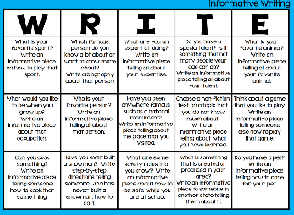 | Writing – Informative writing grid  In your writing book, choose a writing task from the grid and complete it in your writing book | Writing – Informative writing grid  In your writing book, choose a writing task from the grid and complete it in your writing book | Writing – Informative writing grid  In your writing book, choose a writing task from the grid and complete it in your writing book
BREAK
Middle | Whole number –  Complete as many of the ‘Math Investigation task cards as you can. | Interpreting Pictograms –  Complete the ‘Interpreting Scaled Pictograms’ worksheet by answering the questions. | Pets bar graph –  Complete the ‘Pets Bar Graph’ worksheet by shading in the boxes according to the tally column. Then complete the questions on the back. | Ice Cream Statistics –  Complete the ‘Ice Cream Statistics’ worksheet by creating a bar graph. | Good Friday  Public  Holiday
BREAK
Afternoon | Visual Arts  Complete the daffodil origami by following the instructions on the worksheet. | Science  Tell a family member what a living thing is. Go on an adventure into your backyard and try to find 3 living things.  Draw them in your science book. | PDHPE - Fitness  Roll the dice and perform the matching exercise for 30 minutes. | PDHPE  Complete the ‘Gratitude Grid’ with things that you are thankful for. | Good Friday  Public  Holiday

*** CAN DO GRID ***
Ask your family members which chores you can help them do today. | Draw a self-portrait of yourself | What can you do to be kind to a family member today? | Put on a song and create your dance moves.  You can upload a video of you dancing to our Google Classroom.
Get onto www.studyladder.com.au and complete some tasks. If you forget your log in details, email your teacher | Do some Easter egg mindfulness colouring in with the templates attached to your booklet | Food is fuel! Keep a food diary by drawing and labelling everything you eat for an entire day. | Listen to a story on Storyline Online  https://www.storylineonline.net/
Make an Easter Hat or an Easter basket | Create some music using  Chrome Music Lab  https://musiclab.chromeexperiments.com/ | Complete the multiplication wheel activity attached to your booklet | - Laughing boosts our mood! Think of 3 jokes you could tell a family member. Write them down.

