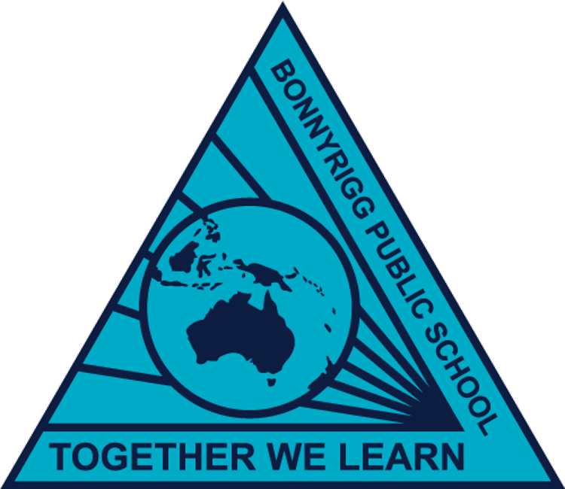
Bonnyrigg Public School Behaviour Support and Management Plan
Reviewed: May 2023
To be Reviewed: January 2024
Overview
Bonnyrigg Public School is committed to explicitly teaching and modelling positive behaviour and to supporting all students to be engaged with their learning. Key programs prioritised and valued by the school community are Positive Behaviour for Leanring and the Berry Street Education Model.
Pre-reading and reference documents
Student Behaviour Procedures Kindergarted to Year 12
Behaviour Code for Students
Detention and Time-out Guidelines

Staff roles and responsibilities
School principal | The principal holds primary responsibility for the safety and wellbeing of all students and staff.  The principal is responsible for ensuring:  - the school’s behaviour procedures are updated annually as a review process, consulting with the Departments school behaviour procedures.  - all staff are familiar with and use the current behaviour procedures in line with departmental requirements.  - all procedures are current and reviewed as part of a continuous cycle of self- assessment.
Deputy/Assistant Principal | The Deputy/Assistant Principal supports the principal in their role and is responsible for leading and supporting staff with the implementation of the school’s behaviour procedures. This could include:  - Manage all tier 2 and 3 behaviours, consulting with parent/caregivers on matters of concern  - reflect with students on their behaviour of concern and work on strategies moving forward.  - Refer students to LST when behaviours become a concern to wellbeing and safety of others.
All Staff | Staff support student behaviour within their classroom and whole school by promoting positive behaviour and managing behavioirus of concern. this includes;  - Following all PBL and Berry St procures in line with school procedures and expectations.  - Manage low level tier 1 behaviours in the classroom and on the playground.  - Refer students to supervisor when behaviours becoming concerning.

Promoting and reinforcing positive student behaviour and school-wide expectations

Bonnyrigg Public School has the following school-wide rules and expectations:
To be Safe, Respectful and Engaged in all areas of the school. What this looks like i s;
- Hands and feet to yourself
- Use furniture and equipment appropriately
- Hand up and wait to speak
- Follow instructions
- Always try your best
- Right place, right time

Bonnyrigg Public School uses the following strategies and systems to explicitly teach, recognise and reinforce positive student behaviour and behavioural expectations:
Positive Behaviour for Learning
A whole school approach to explicitly teaching and modeling positive behaviour. Expectations and desired behaviorus are taught during explicit lessons, with a fortnightly focus put forward to students to work towards an identified target. Students are rewarded in accordance with the positive behaviour model and students work towards a major school award through exhibiting positive behaviour and engagement in their learning.
Berry Street Education Model
A trauma informed practice that creates a safe space for students to succeed and thrive. Built of consistent, predictable routines, relationships are established between the teacher and the students to ensure we are all ready to learn at all stage of the school day. Student wellbeing is supported through regular check in’s and activities to support their learning such as, brain breaks, morning circle and mindfulness.

Behaviour Code for Students

The Behaviour Code for Students can be found at https://education.nsw.gov.au/policy-library/policies/pd-2006-0316/pd-2006-0316-01. High expectations for student behaviour are established and maintained through effective role modelling, explicit teaching and planned responses.

Whole School Approach
Care Continuum | Strategy or Program | Details | Audience
Prevention | BroSpeak/SistaSpeak | A cultural and mentoring workshop program at our school, which has a strong cultural focus and is designed to inspire and motivate Aboriginal young people about the importance of education. | ATSI Students
Prevention | Berry St | A trauma informed practice that creates a safe space for students to succeed and thrive. Built of consistent, predictable routines, relationships are established between the teacher and the students to ensure we are all ready to learn at all stage of the school day. | All students
Prevention | Mindfulness | SmilingMinds - A mindfulness program to create a calm and safe learning environment. | All students
Prevention | Quality Differentiation | Targeted teaching that is differentiated to meet the students at their point of need to ensure students are engaged. | All students
Early Intervention | Extra-Curricula Activities | Staff provide students with the opportunity to participate in extra-curricula activities to build a sense of belonging. | All students
Early Intervention | SEL Program | Bounce Back - teaches social emotional skills to students through a literacy approach with circle time. | All students
Early Intervention | PBL Tier 1 | Positive Behaviour for Learning (PBL) Tier 1 Schoolwide and classroom systems of support that brings together the whole school community to contribute to developing a positive, safe and supportive learning culture | All students
Targeted Intervention | LaST | The Learning and Support team work with teachers, students and families to support those students who require personalised learning and support. Including instructional leadership, development of risk assessments and the development of short- and long-term goals. | Targeted students
Targeted Intervention | PLP’s | Personlised Learning Pathways include personal goals in which AEO’s target ATSI students and work one on one with to meet the individual academic, cultural and social goals. | ATSI Students
Targeted Intervention | Zones Of Regulation | A program that is aimed at teaching students to manage and reflect on their own emotions with the goal of regulating their own emotions and forming regular social groups. | Targeted students
Individual Intervention | Risk management plans | Plans created to support staff in understanding and managing students with high level behaviours of concern. | LST and AP/DP
Individual Intervention | PLASPS | Individualised learning programs provided for students that will include behavioural goals for students and staff to work towards. | CT, LST, Families

Detention, reflection and restorative practices
Action | When and how long? | Who coordinates? | How are these recorded?
Reflection Room - Students who receive levels will be required to attend reflection room | Time based on level.  Recess and Lunch | AP’s | Sentral
Calm down space - areas within the classrooms that allows students to take themselves out and spend time to gather themselves. | 10 mins during class | CRT | Staff Observations
Movement Breaks - SLSO to take targeted students for movement breaks | 10 mins during class | SLSO and CRT | Individual Timetable

Partnership with parents/carers
Bonnyrigg Public School will partner with parents/carers in establishing expectations for parent engagement in developing and implementing student behaviour management strategies by requiring input from parents in regards to Personalised Learning and Support Plans and Personalised Learning Pathways.
Bonnyrigg Public School will communicate these expectations to parents/carers by coordinating meetings with parents.

School Anti-bullying Plan
Link to website once finalised.

